Online Consent Management & Monitoring System

User Manual for Industries

**GUIDELINES FOR INDUSTRIES TO FILE APPLICATION ONLINE FOR CONSENT OF THE BOARD**

**Meghalaya Pollution Control Committee**

**Revision Sheet**

|  |  |  |
| --- | --- | --- |
| **Release No.** | **Date** | **Revision Description** |
| Rev. 0 | 17/10/2016 | User’s Manual Template and Checklist |
|  |  |  |
|  |  |  |
|  |  |  |
|  |  |  |

# INTRODUCTION

Online Consent Management & Monitoring System is a web based application for Consent Management developed for the MSPCB (Meghalaya State Pollution Control Board), by NIC Cell, and Ministry of Environment & Forest. The details of **Industry User** as given below.

## Features of OCMMS

* Unified Global online application/ portal
* Role based application access
* Multi level Security Enabled System
* Online Industry Registration
* Online Submission of Application, Approval, Clarification and other activities for CTE, CTO for all category of Industries / Institutions

1. **ONLINE INDUSTRY REGISTRATION**

Industry registration is an online feature; which will enable Industry applicant to register himself online to use the application for applying for Consents (CTE/CTO), Authorization and other features. Using this Industry will be able to generate the user temporary name and password, which he needs to use within the stipulated time. Once Industry uses the temporary user name and password for Consent Application; documents/details provided with this will be validated and user name will be confirmed and made available to him for future use. If Industry fails to use the temporary user name within the given time frame, then this user name will be deleted from the database and applicant will have to re-register himself to use the online application.

**For New Industry Registration Click on “New Industry Registration” Link at Home Page.**

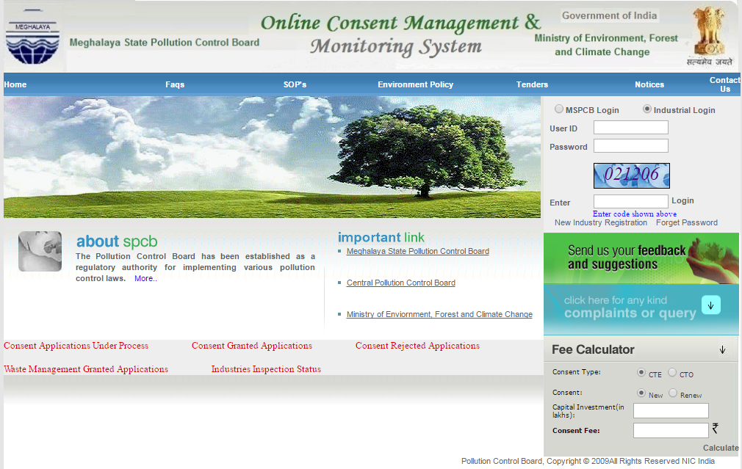

**Screen Shot: Home Page**

# Click “New Industry Registration”.

# 

# Above screen will appear select the radio button as per requirement.

* New Registration form will be displayed accordingly.
* Fill the required details in provided form and click “Submit”.
* Once submitted, System will validate the input data.
* If data is incorrect or mandatory filled not filled then system will prompt user to correct the information.
* If provided info of Industry user is correct then System will generate user name and Temporary password.
* After successful Registration, System will generate User name and temporary password, which will display on screen.
* Following are the screenshots of Industry Details and Occupier details.
* If we select Healthcare Establishment following form will appear.

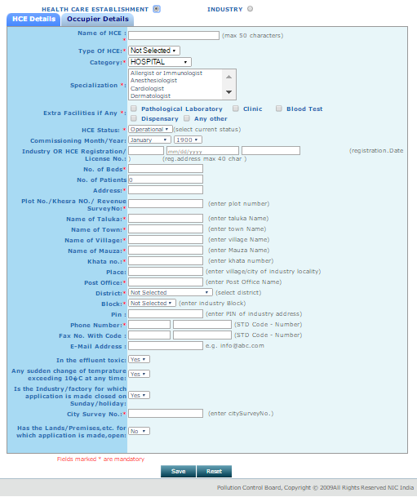

Click on Occupier Details.

Click on HCE Details.

Screenshot: Healthcare establishment form(For HCE Details)

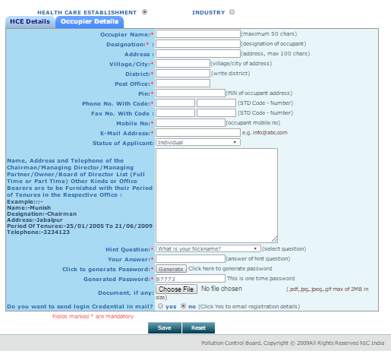

Screenshot: Healthcare establishment form (For Occupier Details)

* Following form will appear if we click Industry form.

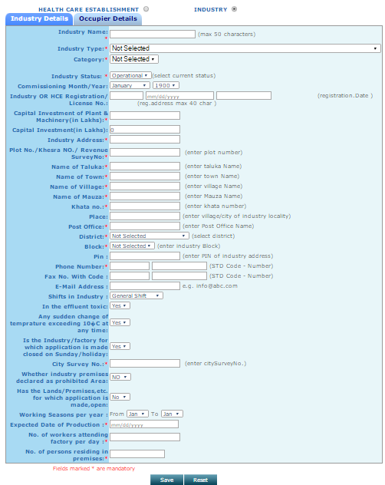

Click on Occupier Details.

Click on Industry Details.

Screenshot: Industry Details

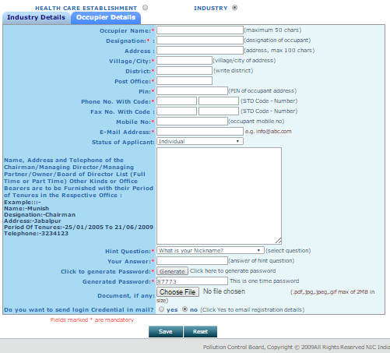

After filling both form completely. Click on Save Button.

Screenshot: Occupier Details.

* Fill all fields of the form correctly and Star marked fields are mandatory to fill, both in Industry Details and Occupier Details.
* After filling the mandatory Industry Details and Occupier Details, click on save button.

1. After successful Registration.

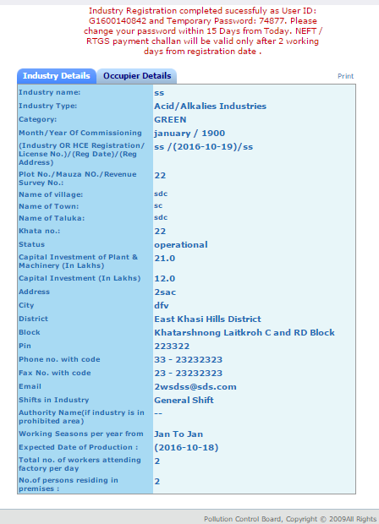

**Screenshot Successful registration**

* After successful Registration, System will generate User name and temporary password, which will display on screen.

1. Login.

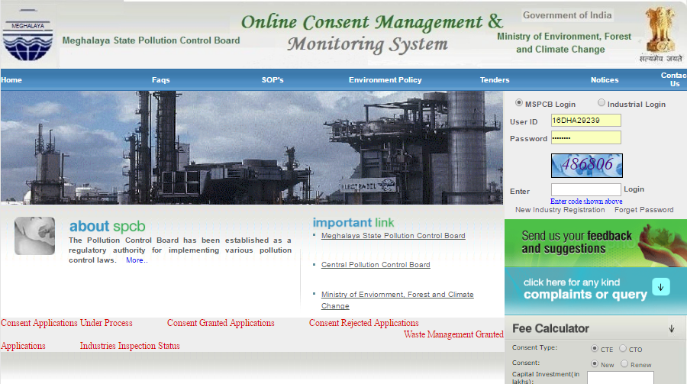

Log in as Industry.

**Screen Shot of login page**

* User need to login with the help of provided user id, Temporary password.
* Automatically change password screen will appear first on login.

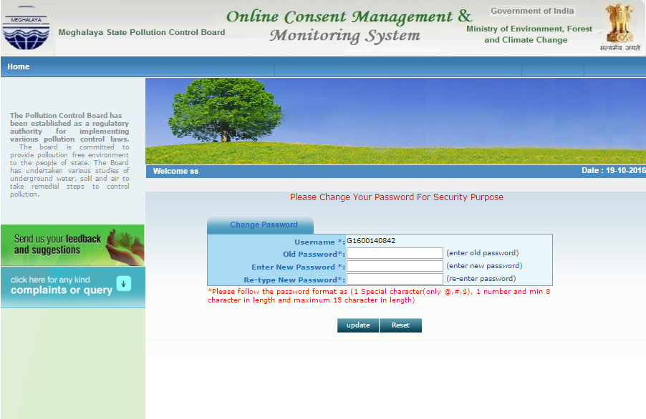

**Screenshot of Password change page**

* When user login as Industry User with provided User ID and Password, firstly it gives change password page as shown here.
* Change temporary password.
* Enter the old & new password.
* Enter the new password of minimum 8 characters size having at least 1 character, 1 digit and 1 special character (@, #, $ only).
* Click on update.
* After changing password successfully, you can login in to OCMMS by selecting radio button Industry and entering user id, password and Captcha code.
* Maximum 3 times you can enter wrong password, after that your account locks.
* Only way to unlock it is doing forget password.

1. Forget Password.

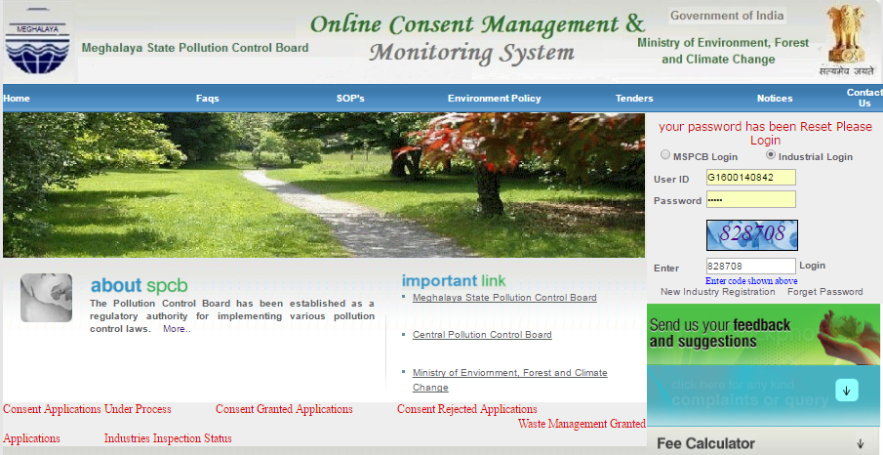

Click on forget password, in case user forgot password or want to reset.

“Error Message” when user enter wrong user id or password.

**Screen shot of Home Page**

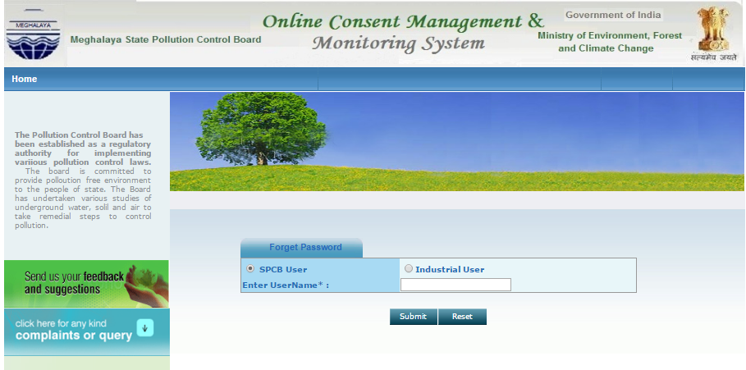

**Screenshot to Reset password.**

**Procedure for Forget Password**

* Click on industrial user Radio Button.
* Provide user name in the field.
* Click on submit button.
* New password will be generated and sent to the registered mobile number and e-Mail ID automatically.

Now, Login can be done using new password.

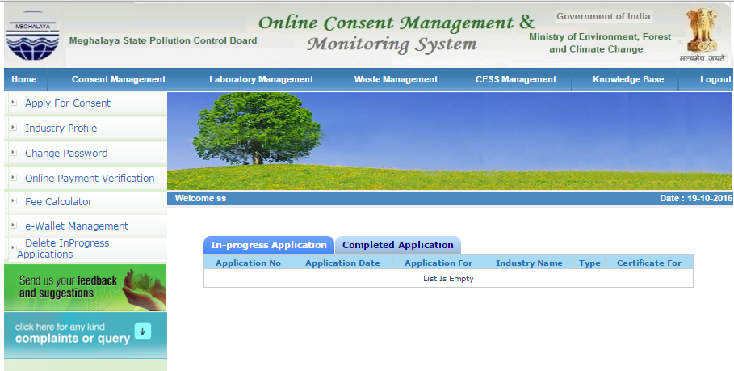

**Screenshot of Tabs- Inprogress and Completed application.**

* After logging in, the page appears as shown alongside.
* In progress application or completed application status can be viewed if already applied online.

1. Industry Profile:

Logout Button

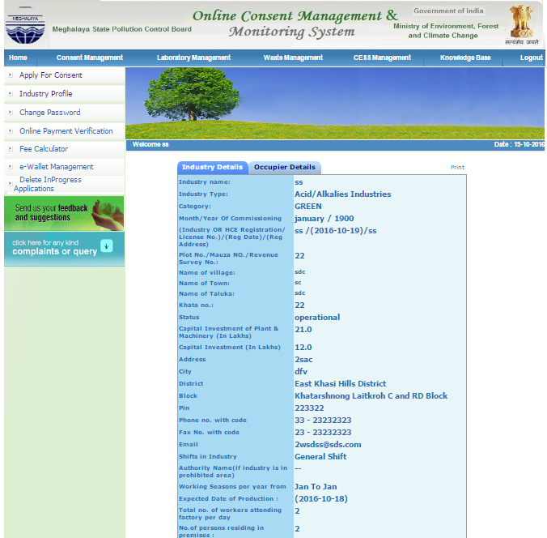

With help of Industry profile user can check details provided by them during registration and can edit it.

Industry and Occupier details.

User can also print Industry and Occupier details.

1. Apply for Consent.

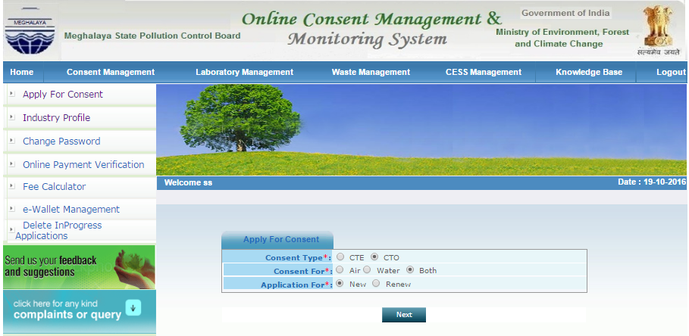

Screenshot of Apply for Consent

* Click on Apply for consent.
* Click on Consent Type as per requirement.

In case of CTE🡪Air🡪New

🡪Air🡪Modernization

🡪Air🡪Expansion

In case of CTE🡪Water🡪New

🡪 Water 🡪Modernization

🡪 Water 🡪Expansion

In case of CTE🡪Both🡪New

🡪 Both 🡪Modernization

🡪 Both 🡪Expansion

In case of CTO🡪 Air🡪New

🡪Air🡪Renew

🡪 Water🡪New

🡪Water🡪Renew

🡪 Both🡪 New

🡪 Both🡪 Renew

* Click on consent for as per requirement.
* Click on Application for as per requirement.
* Click on Next.

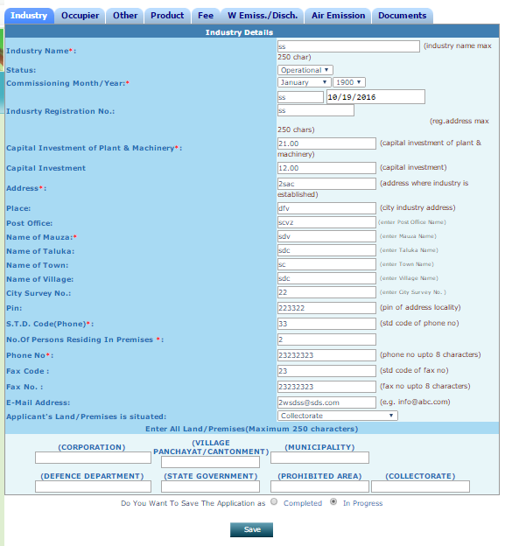

Click on industry or Occupier to view the industry Details.

**Screenshot of Industry Details.**

* Click in Industry details to view the Industry details.
* Click in Occupier details to view the Industry Occupier details.
* Click on Other tab to proceed for filling the application.

Fill in the required details; do not miss the fields that are marked mandatory

7.1 Other Tab.

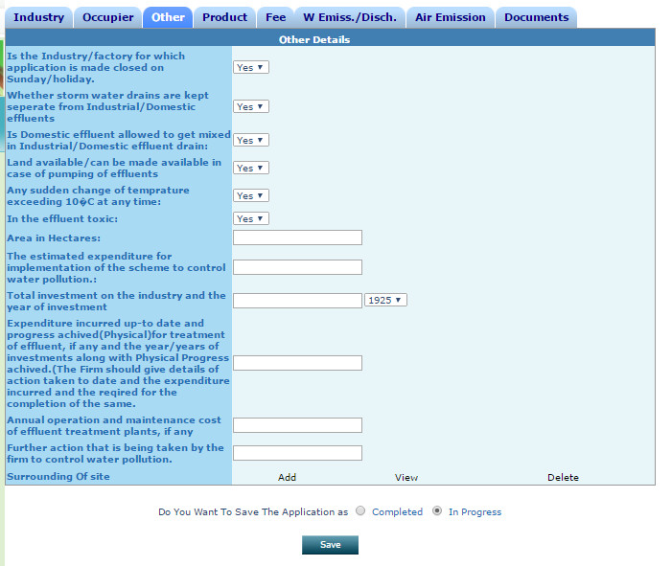

Click on in progress.

Please do not click on completed until it is completed.

Click on Save button.

Here we can view the details added.

Click on Add button to fill details

Click on Delete to erase details added.

Click on Other tab to proceed for filling the application

**Screenshot of Other Tab.**

* Click **Save** in **“In Progress Mode”**
* Important: **Please do not click “Completed mode”** until application is fully completed.

# **7.2 Product Tab**

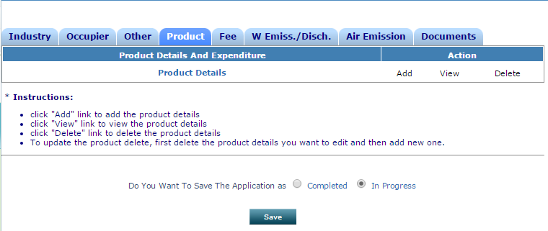

**Screenshot of Product Tab.**

* Click on Product tab.
* Provide Product details
* Fill form accordingly.

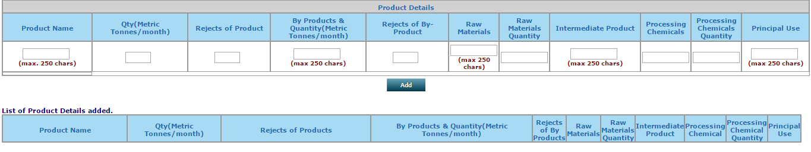

* Fill form accordingly..
* Click on add button to enter multiple details.

**7.3 Fee tab**

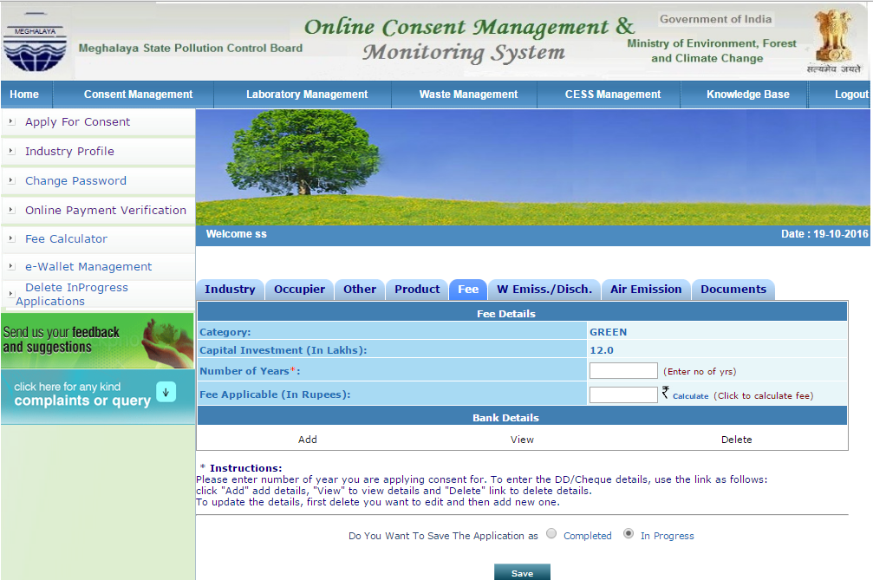

Auto Fill

Click to know the Fees.

Enter No. of years.

* Click on Energy tab.
* Provide Energy details
* Fill form accordingly.
* Click on add button to enter more details.

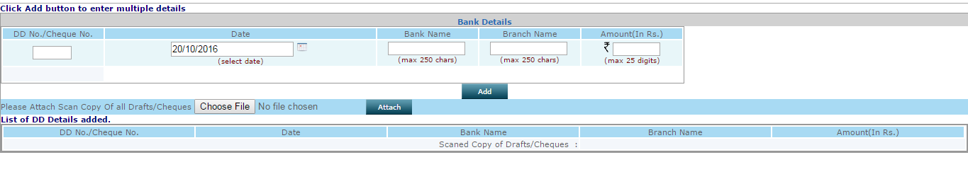

* Provide DD No./ Cheque No.
* Attache copy of DD or Bankers cheque.

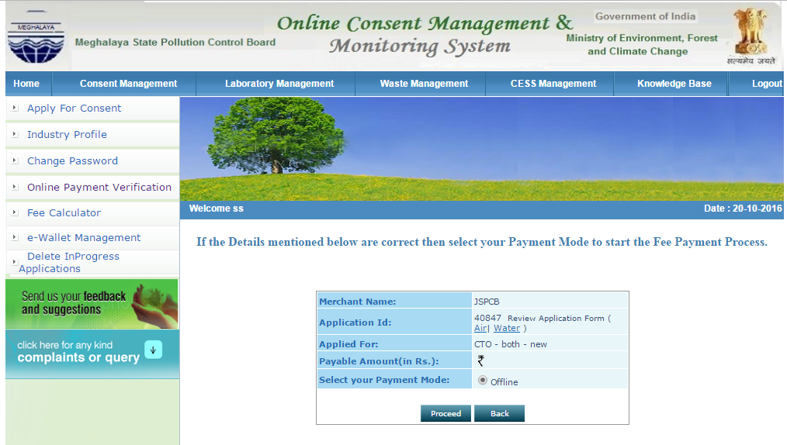

* Click on proceed button.

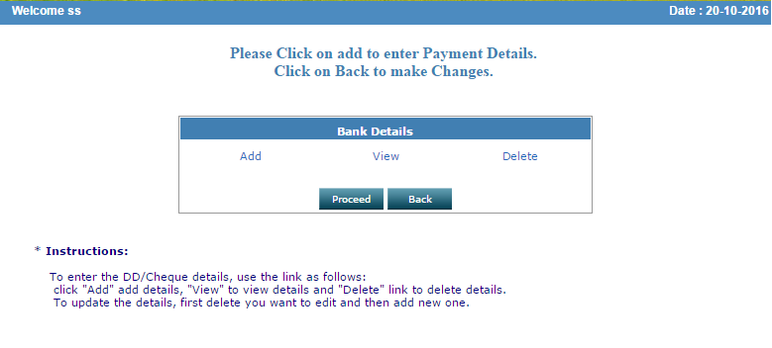

**7.4 W Emiss./ Discharge**

* Click on WEmiss./ Discharge tab.
* Provide WEmiss./ Discharge details
* Fill form accordingly.

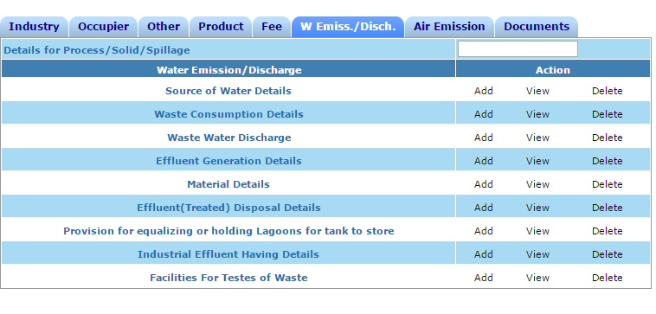

**7.5 Air Emission**

* Click on Air Emission tab.
* Provide Air Emission details
* Fill form accordingly.
* Click on add button to enter more details.

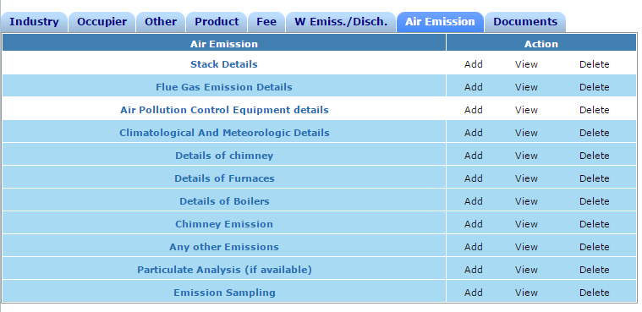

**7.6 Document**

* Click on Document tab.
* Provide Document details
* Fill form accordingly.

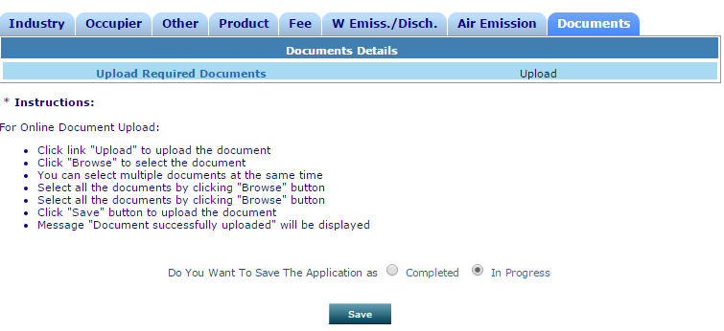

* Click on upload button for uploading document.
* Upload file less than 5 MB.

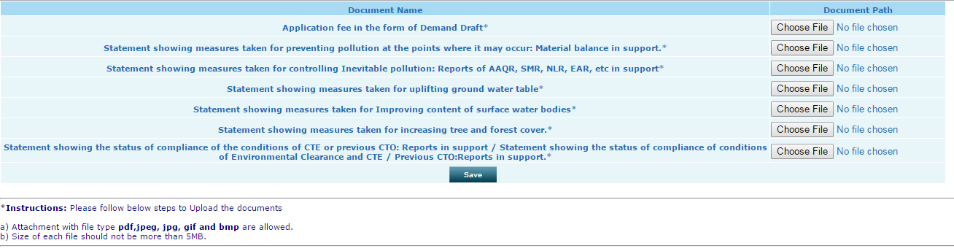

* Following message will display after successful registration.



* After filling forms under all tabs, especially mandatory fields.
* Finally save in completed mode instead of in progress mode.
* Following message will display on successful completion of application.

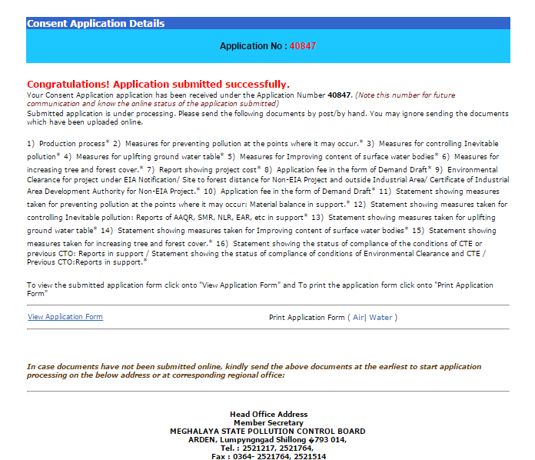

* Click on home.
* Pending applications will come under in progress application and Completed application will come under completed application.

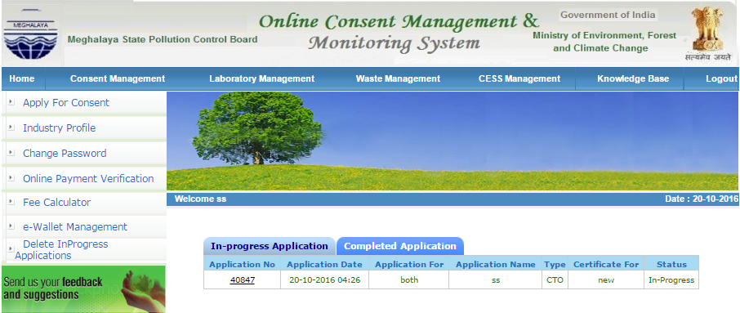

* If application is completed, click on completed tab.
* Click on application no. link.
* Following screen will appear.

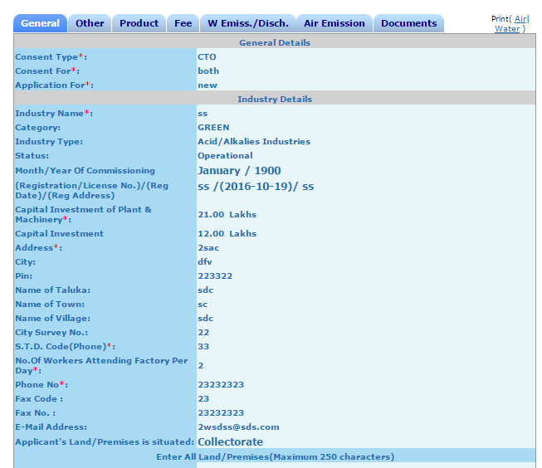

* Click on print,

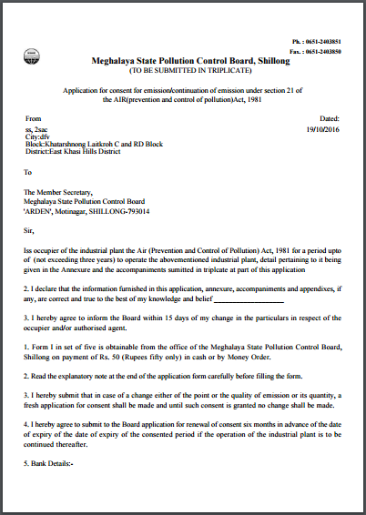

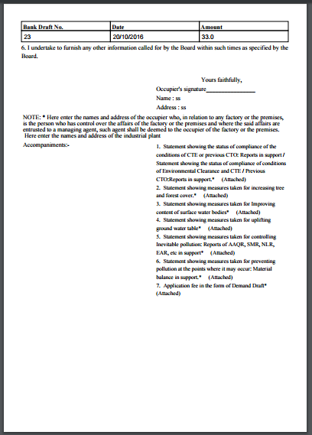

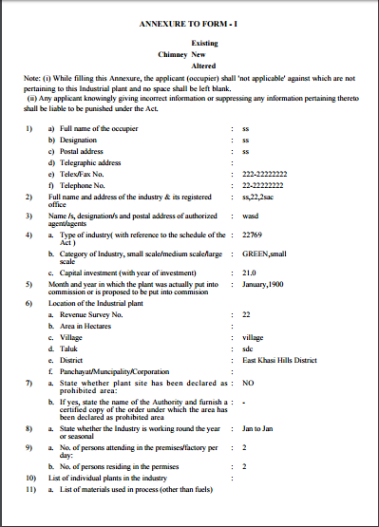

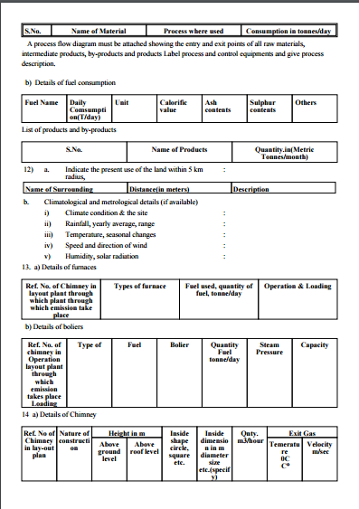

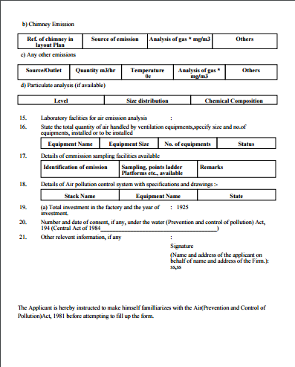

* Finally application is forwarded to SPCB end,

Thank You.